here are information from <https://medlineplus.gov/guidetogoodposture.html>

Home->Health Topics->Guide to Good Posture

**Guide to Good Posture**

**Summary**

Good posture is about more than standing up straight so you can look your best. It is an important part of your long-term health. Making sure that you hold your body the right way, whether you are moving or still, can prevent pain, injuries, and other health problems.

**What is posture?**

Posture is how you hold your body. There are two types:

* **Dynamic posture** is how you hold yourself when you are moving, like when you are walking, running, or bending over to pick up something.
* **Static posture** is how you hold yourself when you are not moving, like when you are sitting, standing, or sleeping.

It is important to make sure that you have good dynamic and static posture.

The key to good posture is the position of your spine. Your spine has three natural curves - at your neck, mid back, and low back. Correct posture should maintain these curves, but not increase them. Your head should be above your shoulders, and the top of your shoulder should be over the hips.

**How can posture affect my health?**

Poor posture can be bad for your health. Slouching or slumping over can:

* Misalign your musculoskeletal system
* Wear away at your spine, making it more fragile and prone to injury
* Cause neck, shoulder, and [back pain](https://medlineplus.gov/backpain.html)
* Decrease your flexibility
* Affect how well your joints move
* Affect your [balance](https://medlineplus.gov/balanceproblems.html) and increase your risk of [falling](https://medlineplus.gov/falls.html)
* Make it harder to digest your food
* Make it harder to breathe

**How can I improve my posture in general?**

* **Be mindful of your posture** during everyday activities, like watching television, washing dishes, or walking
* **Stay active.** Any kind of exercise may help improve your posture, but certain types of exercises can be especially helpful. They include yoga, tai chi, and other classes that focus on body awareness. It is also a good idea to do exercises that strengthen your core (muscles around your back, abdomen, and pelvis).
* **Maintain a healthy weight.** Extra weight can weaken your abdominal muscles, cause problems for your pelvis and spine, and contribute to low back pain. All of these can hurt your posture.
* **Wear comfortable, low-heeled shoes.** High heels, for example, can throw off your balance and force you to walk differently. This puts more stress on your muscles and harms your posture.
* **Make sure work surfaces are at a comfortable height** for you, whether you're sitting in front of a computer, making dinner, or eating a meal.

**How can I improve my posture when sitting?**

Many Americans spend a lot of their time sitting - either at work, at school, or at home. It is important to sit properly, and to take frequent breaks:

* **Switch sitting positions** often
* **Take brief walks** around your office or home
* **Gently stretch your muscles** every so often to help relieve muscle tension
* **Don't cross your legs;** keep your feet on the floor, with your ankles in front of your knees
* **Make sure that your feet touch the floor,** or if that's not possible, use a footrest
* **Relax your shoulders;** they should not be rounded or pulled backwards
* **Keep your elbows in close to your body.** They should be bent between 90 and 120 degrees.
* **Make sure that your back is fully supported.** Use a back pillow or other back support if your chair does not have a backrest that can support your lower back's curve.
* **Make sure that your thighs and hips are supported.** You should have a well-padded seat, and your thighs and hips should be parallel to the floor.

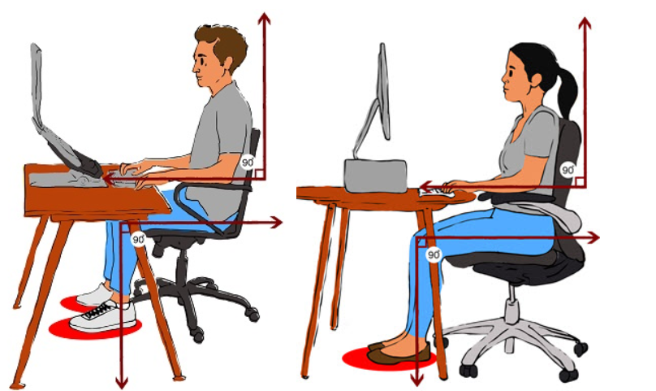

**How can I improve my posture when standing?**

* **Stand up straight and tall**
* **Keep your shoulders back**
* **Pull your stomach in**
* **Put your weight mostly on the balls of your feet**
* **Keep your head level**
* **Let your arms hang down naturally at your sides**
* **Keep your feet about shoulder-width apart**

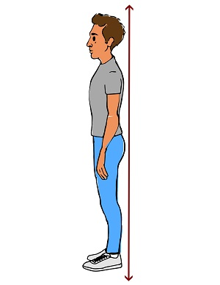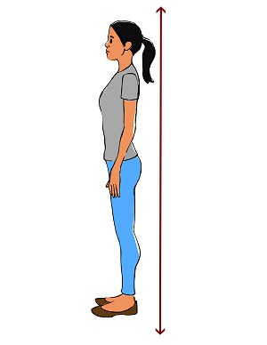

With practice, you can improve your posture; you will look and feel better.

**Learn More**

* [Axial Extension (Posture Exercise)](https://www.nationaljewish.org/education/health-information/exercise-and-weight/exercise-at-home/axial-extension) (National Jewish Health)
* [Computer Workstations: Good Working Positions](https://www.osha.gov/etools/computer-workstations/positions) (Occupational Safety and Health Administration)
* [Getting It Straight: Improve Your Posture for Better Health](https://newsinhealth.nih.gov/2017/08/getting-it-straight) From the National Institutes of Health (National Institutes of Health)Also in [Spanish](https://salud.nih.gov/recursos-de-salud/nih-noticias-de-salud/sentarse-derecho)
* [Maintaining Good Posture](https://www.acatoday.org/patients/posture/) (American Chiropractic Association)
* [Neck pain](https://medlineplus.gov/ency/article/003025.htm) (Medical Encyclopedia)Also in [Spanish](https://medlineplus.gov/spanish/ency/article/003025.htm)
* [Prevent Back Pain](https://odphp.health.gov/myhealthfinder/healthy-living/safety/prevent-back-pain) Easy-to-Read (Office of Disease Prevention and Health Promotion)Also in [Spanish](https://odphp.health.gov/espanol/myhealthfinder/viviendo-sanamente/precauciones-seguridad/prevenir-dolor-espalda)
* [Shoulder Blade Squeeze (Posture Exercise)](https://www.nationaljewish.org/education/health-information/exercise-and-weight/exercise-at-home/shoulder-blade-squeeze) (National Jewish Health)
* [Taking care of your back at home](https://medlineplus.gov/ency/article/002119.htm) (Medical Encyclopedia)Also in [Spanish](https://medlineplus.gov/spanish/ency/article/002119.htm)
* [Yoga for health](https://medlineplus.gov/ency/patientinstructions/000876.htm) (Medical Encyclopedia)Also in [Spanish](https://medlineplus.gov/spanish/ency/patientinstructions/000876.htm)

**Journal ArticlesReferences and abstracts from MEDLINE/PubMed (National Library of Medicine)**

* [Article: Potential of Individual Upper-Limb Muscles to Contribute to Postural Tremor: Simulations...](https://www.ncbi.nlm.nih.gov/pubmed/40027118)
* [Article: Screening of Clinical Data of Patients with Abnormal Head Posture and...](https://www.ncbi.nlm.nih.gov/pubmed/40013480)
* [Article: The investigation of relationship between allergic rhinitis with forward head posture...](https://www.ncbi.nlm.nih.gov/pubmed/40012039)
* [Guide to Good Posture -- see more articles](https://pubmed.ncbi.nlm.nih.gov/?term=%22Posture%22%5Bmajr%3Anoexp%5D+AND+humans%5Bmh%5D+AND+english%5Bla%5D+AND+%22last+1+Year%22+%5Bedat%5D+NOT+%28letter%5Bpt%5D+OR+case+reports%5Bpt%5D+OR+editorial%5Bpt%5D+OR+comment%5Bpt%5D%29+AND+free+full+text%5Bsb%5D+)

**National Institutes of Health**

The primary NIH organization for research on *Guide to Good Posture* is the [National Institute of Arthritis and Musculoskeletal and Skin Diseases](http://www.niams.nih.gov/)

**Disclaimers**

MedlinePlus links to health information from the National Institutes of Health and other federal government agencies. MedlinePlus also links to health information from non-government Web sites. See our [disclaimer](https://medlineplus.gov/disclaimers.html) about external links and our [quality guidelines](https://medlineplus.gov/criteria.html).

The information on this site should not be used as a substitute for professional medical care or advice. Contact a health care provider if you have questions about your health.